**ARYAMAN MISHRA**

**19BCE1027**

**LAB 12-Exploring Information Auditing Tool**

**Tool:Lynis**

Lynis is an open source security tool. It helps with auditing systems running UNIX-alike systems (Linux, macOS, BSD), and providing guidance for system hardening and compliance testing. This document contains the basics to use the software.

By running 'lynis' the program is started and will provide the basic parameters available. If you manually extracted Lynis (or used Git), then use './lynis' to start the program from the local directory.

The most common command to start Lynis is using **audit system** command. This still start the security scan.

To run Lynis you should meet one requirement: have write access to **/tmp** (temporary files)

The Lynis tool requires a minimum amount of parameters to run. If you are using it for the first time, just run lynis and see what output it provides.

$ ./lynis

Without any commands, Lynis will display its status, together with suggestions on how to start.

#### Audit

The audit command tells Lynis to perform an audit.

Targets include:

* **system** - audit the host system
* **dockerfile** - audit a dockerfile

#### Show

The show command informs Lynis to share information, like help or the value of something.

Examples:

* **help** - show help and tips
* **profiles** - show discovered audit profiles
* **settings** - show active settings
* **version** - show Lynis version

#### Parameters

In the table below, the most commonly used parameters are listed.

| Parameter | Abbreviated | Description |
| --- | --- | --- |
| --auditor "Name" |  | Assign an auditor name to the audit (report) |
| --checkall | -c | Start the check |
| --check-update |  | Check if Lynis is up-to-date |
| --cronjob |  | Run Lynis as cronjob (includes -c -Q) |
| --help | -h | Shows valid parameters |
| --manpage |  | View man page |
| --nocolors |  | Do not use any colors |
| --pentest |  | Perform a penetration test scan (non-privileged) |
| --quick | -Q | Don't wait for user input, except on errors |
| --quiet |  | Only show warnings (includes --quick, but doesn't wait) |
| --reverse-colors |  | Use a different color scheme for light backgrounds |
| --version | -V | Check program version (and quit) |

Installing Lynis on Kali Linux.

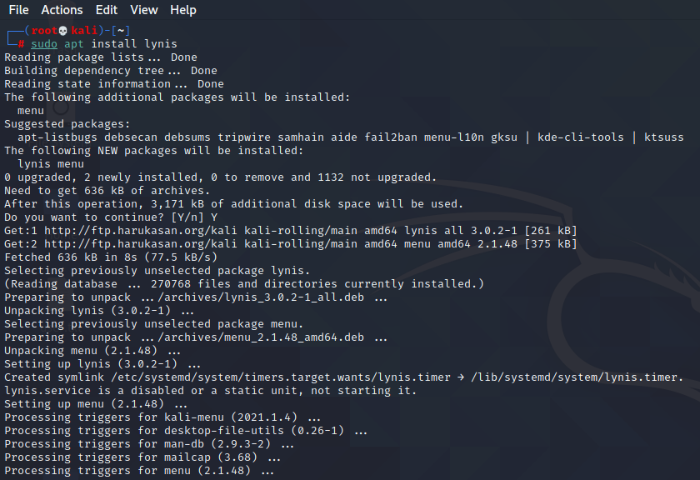

Execute Lynis -h for command details

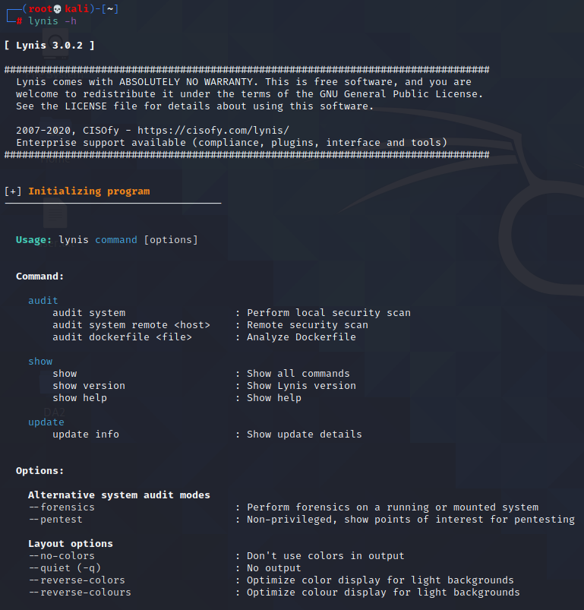

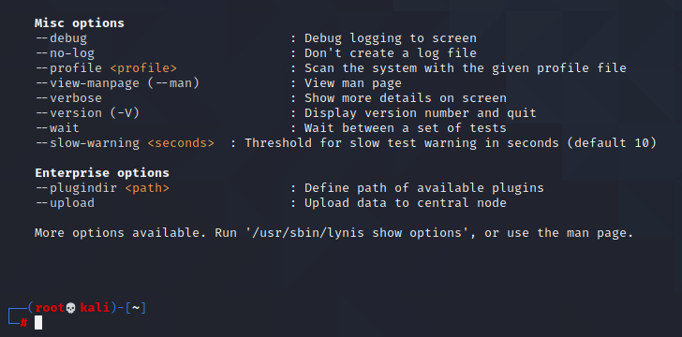

Lynis Audit System command execution:

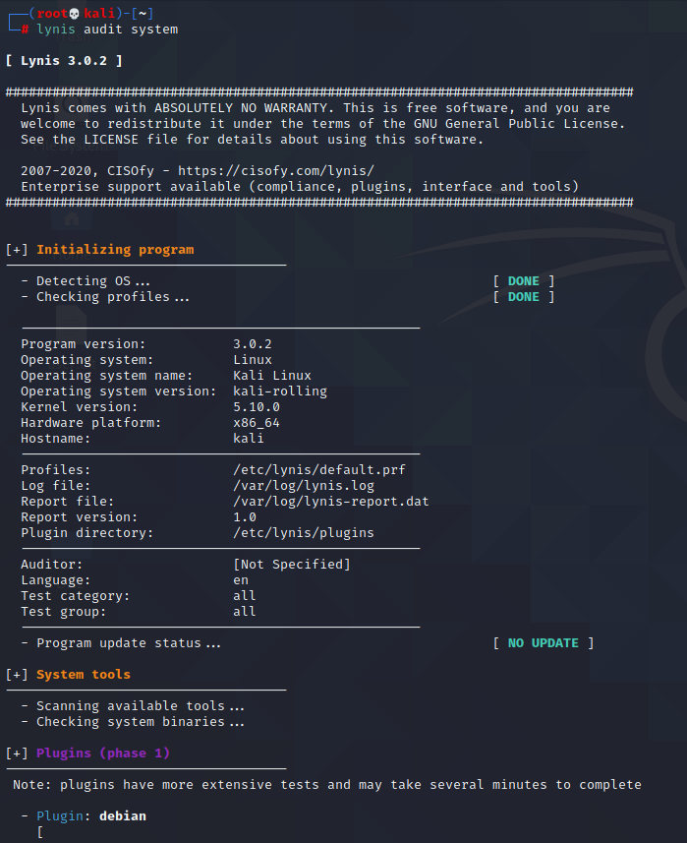

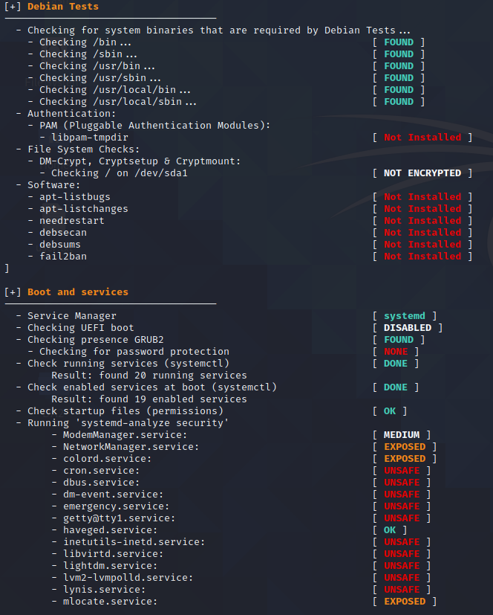

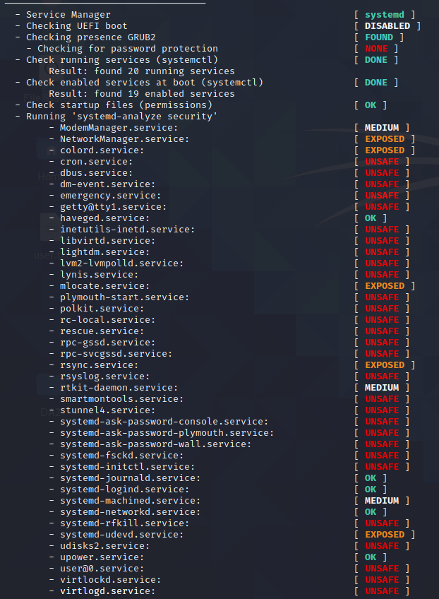

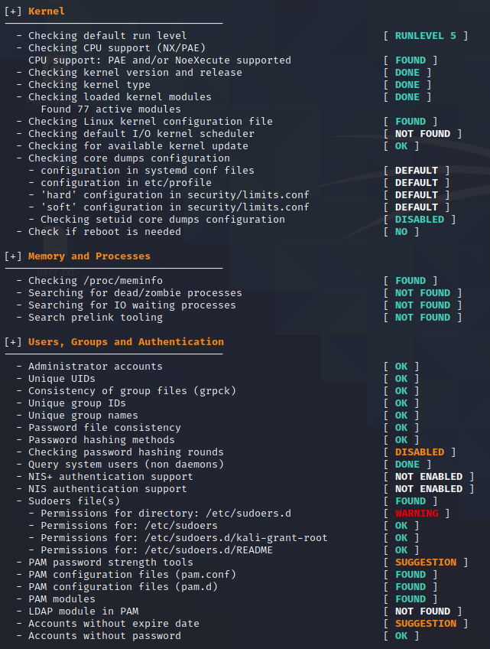

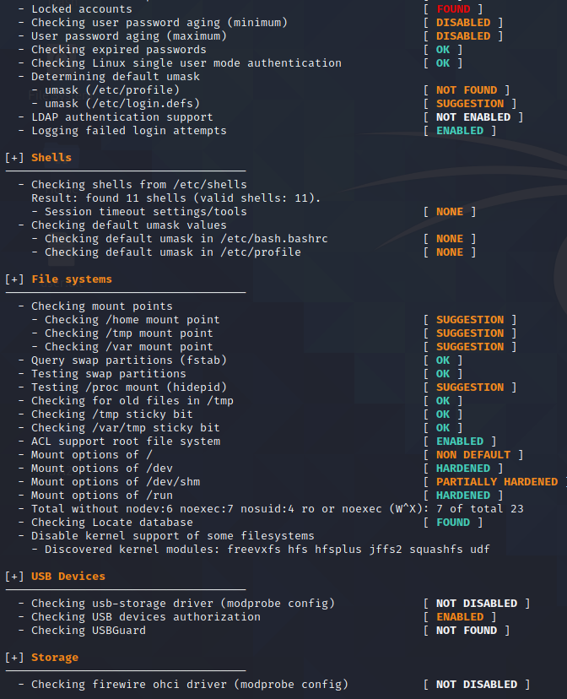

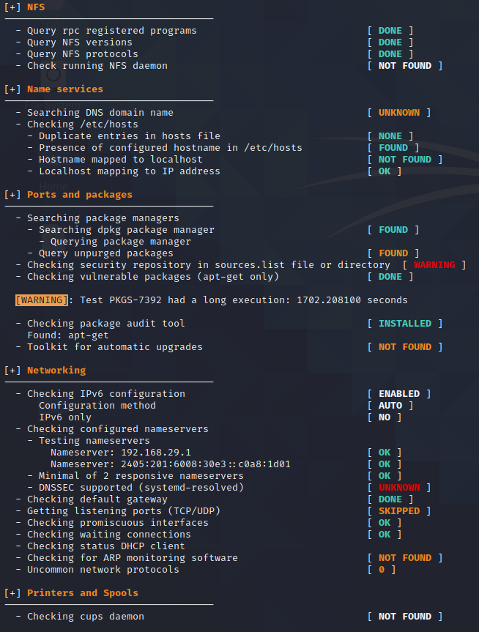

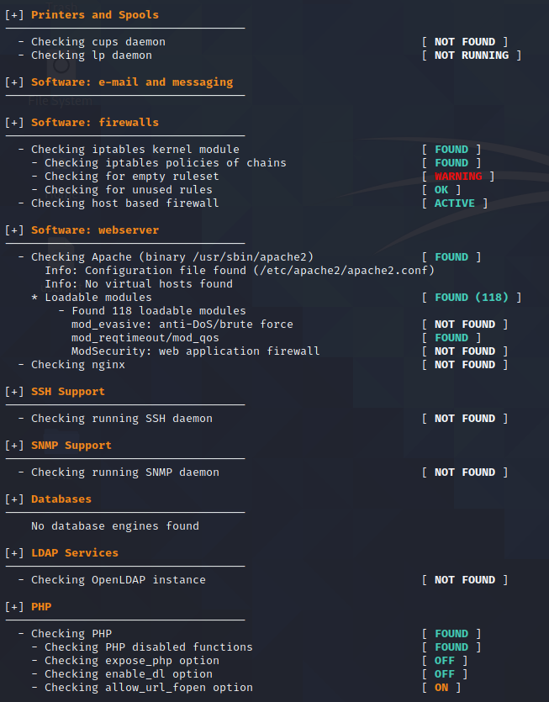

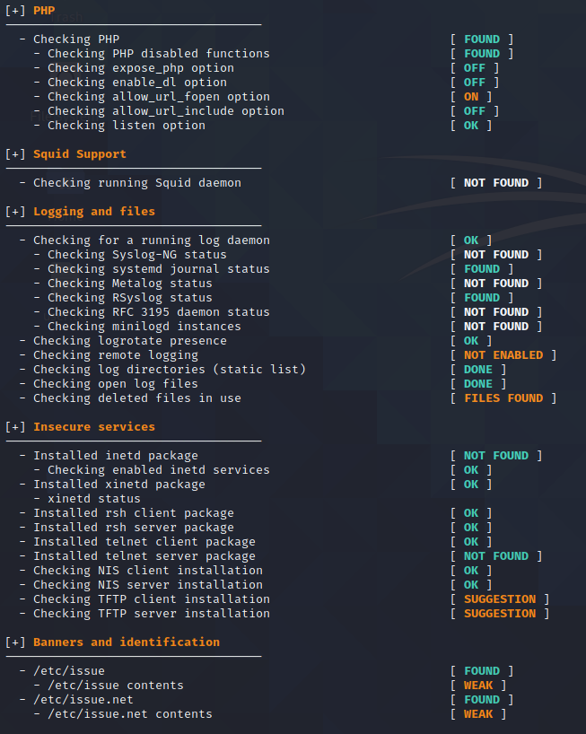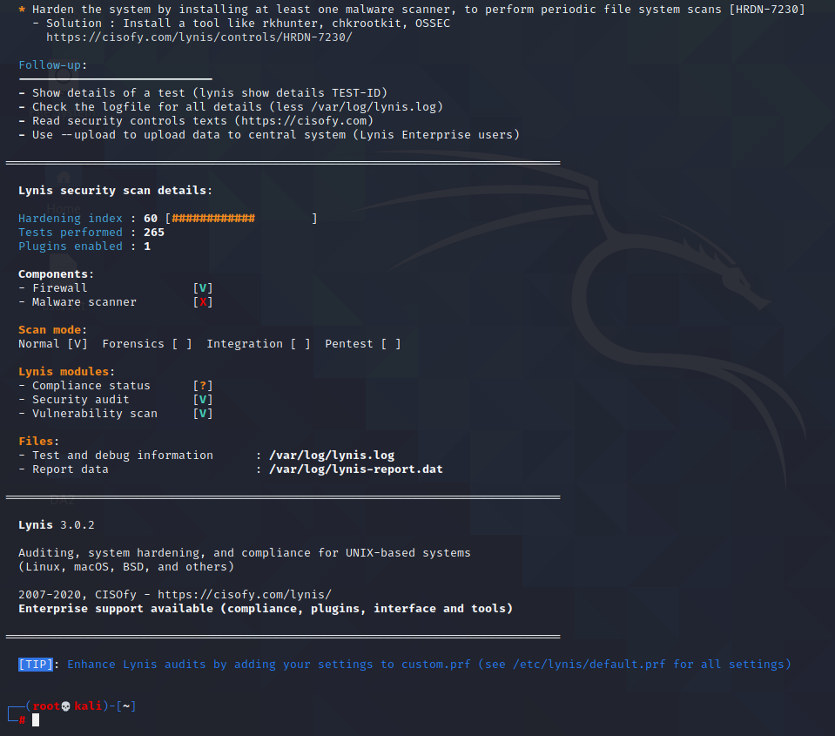

Executing lynis audit system --forensics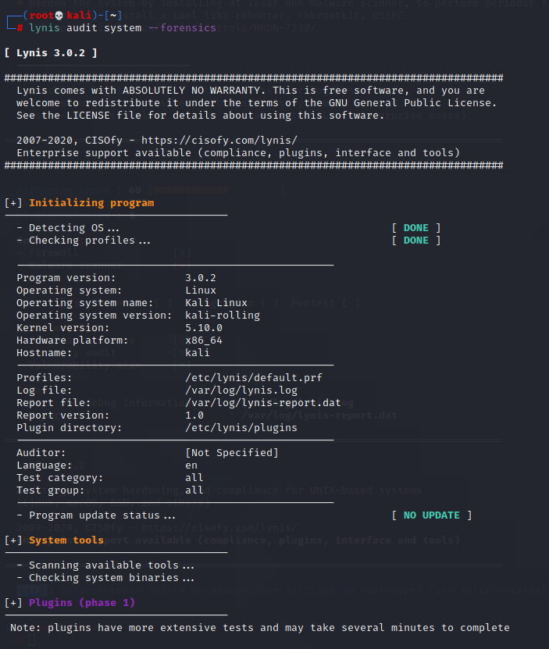

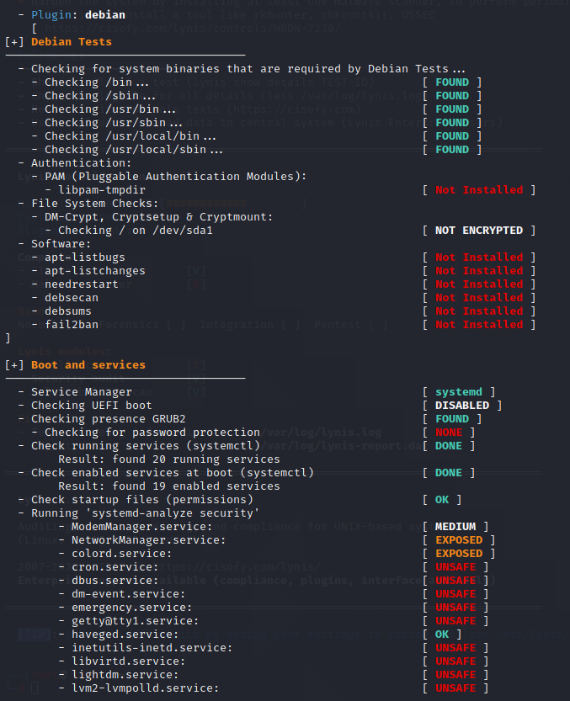

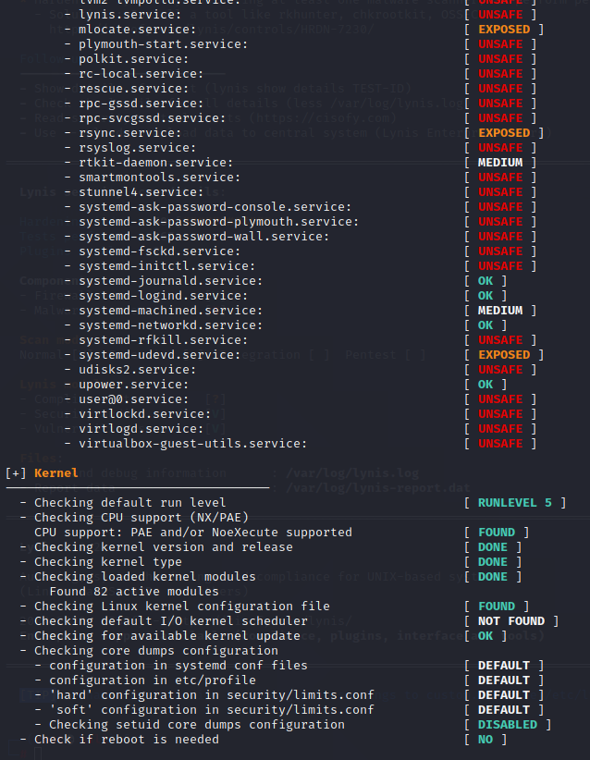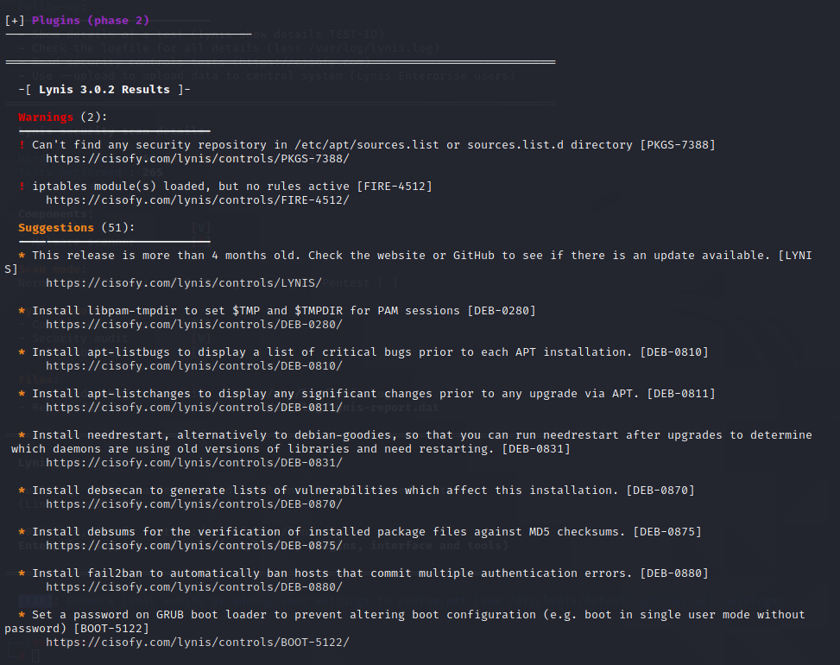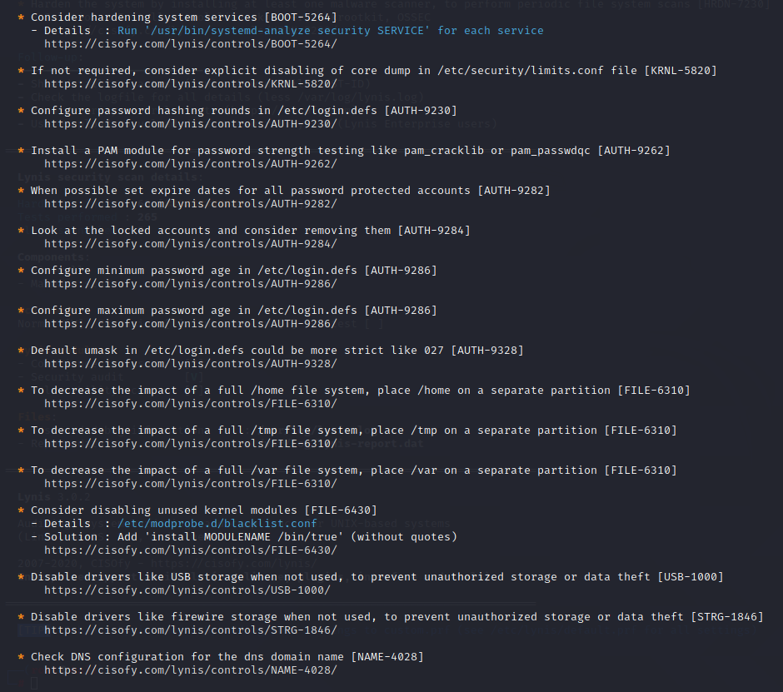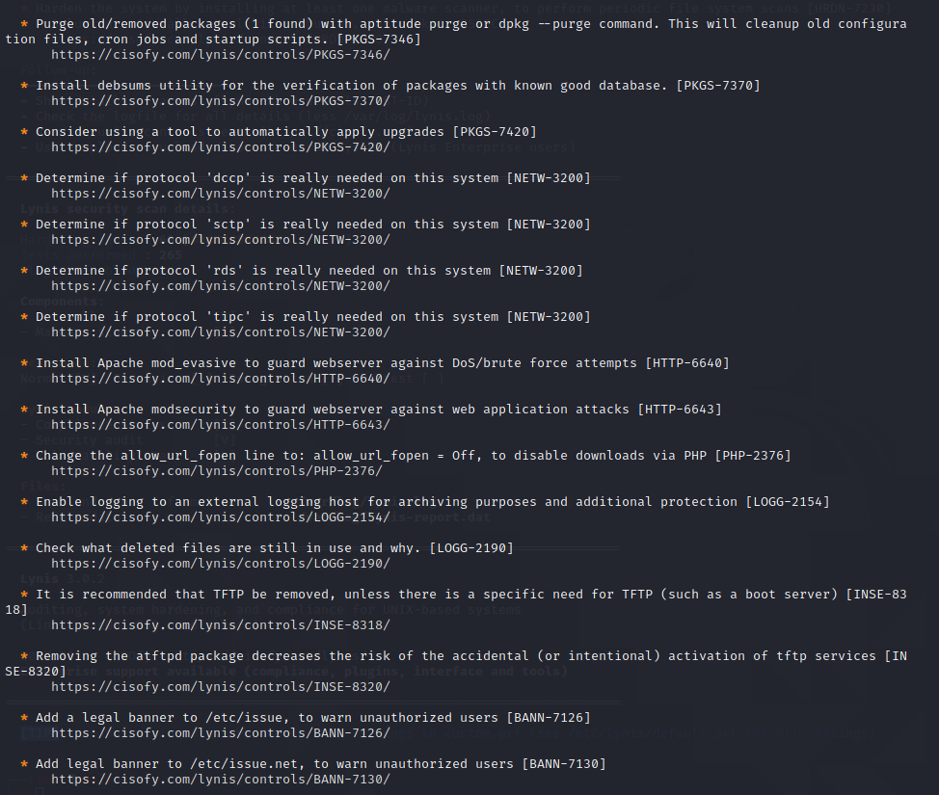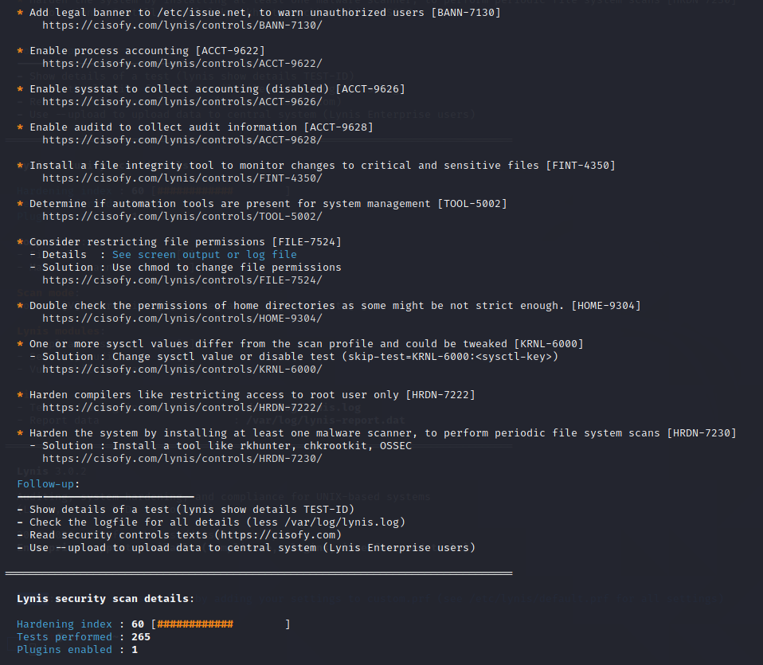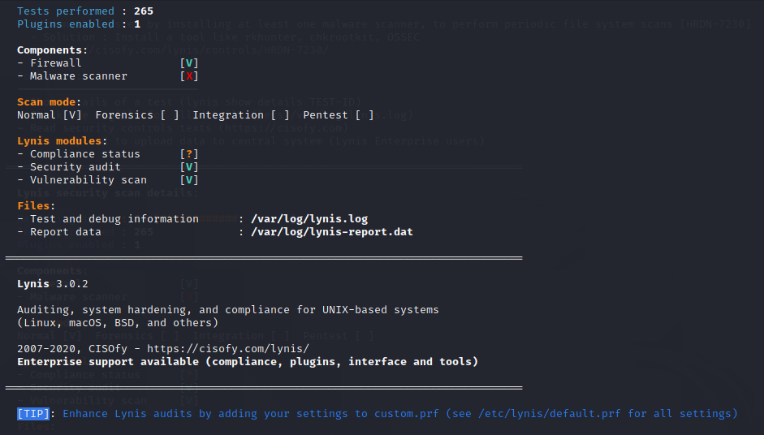

Executing Lynis Audit system –pentest command:

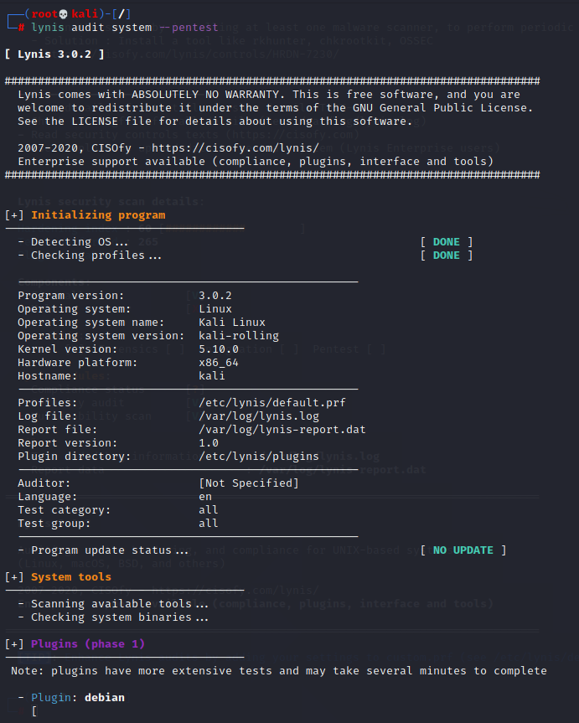

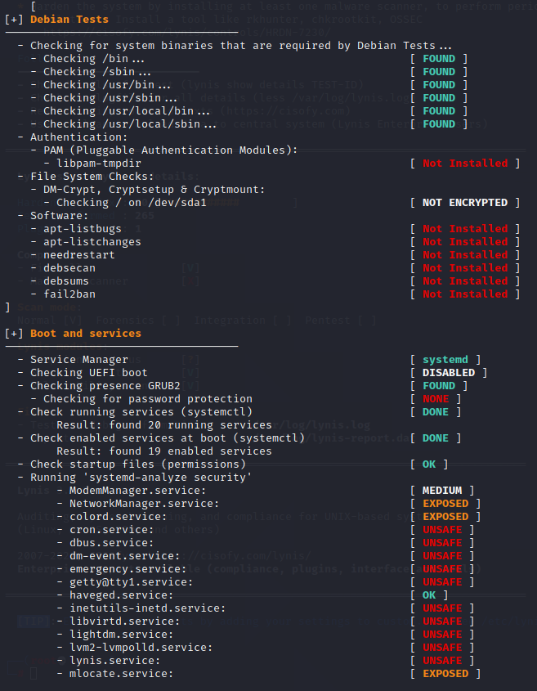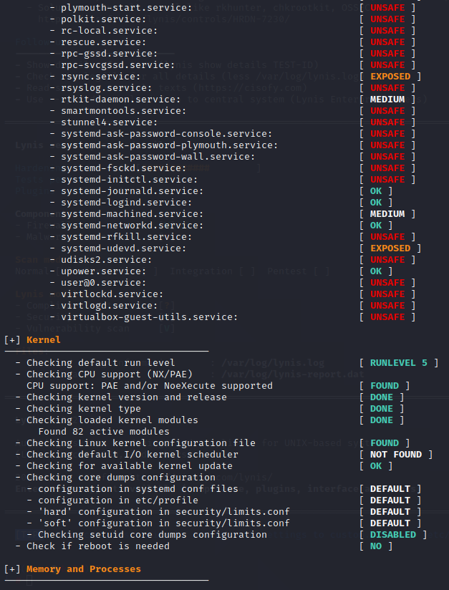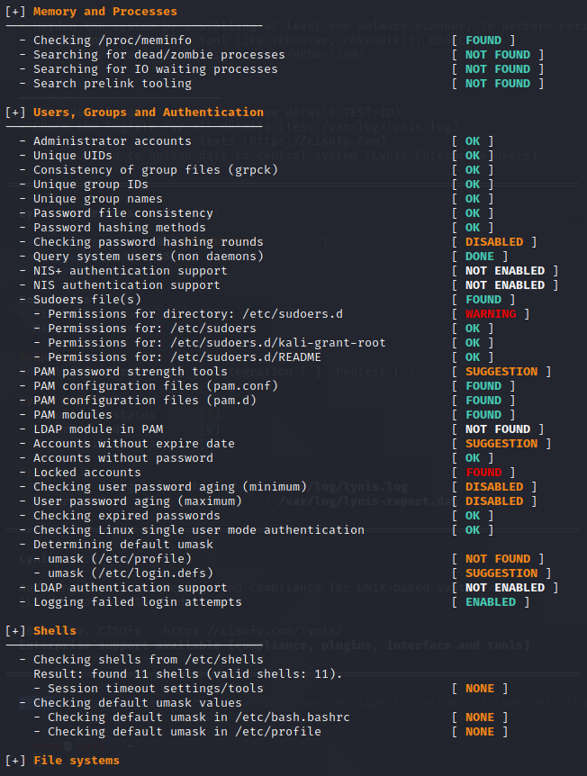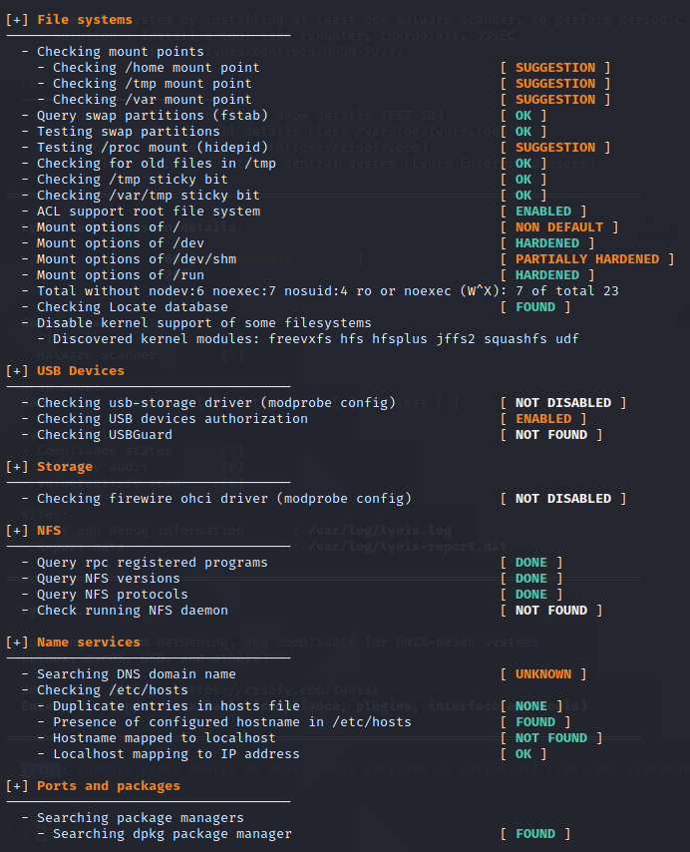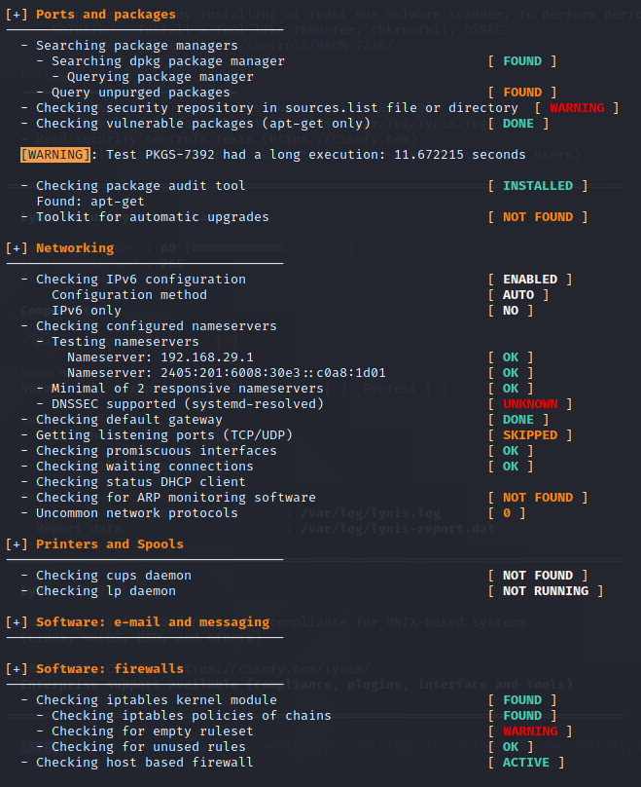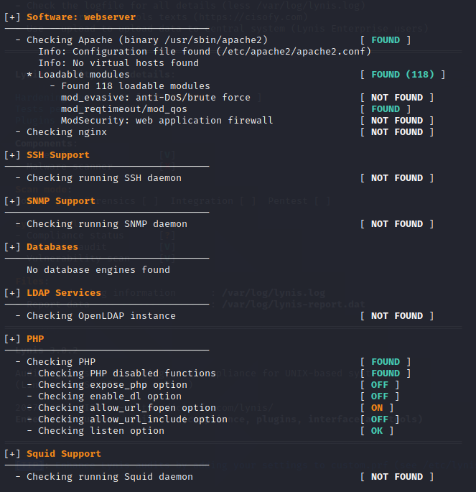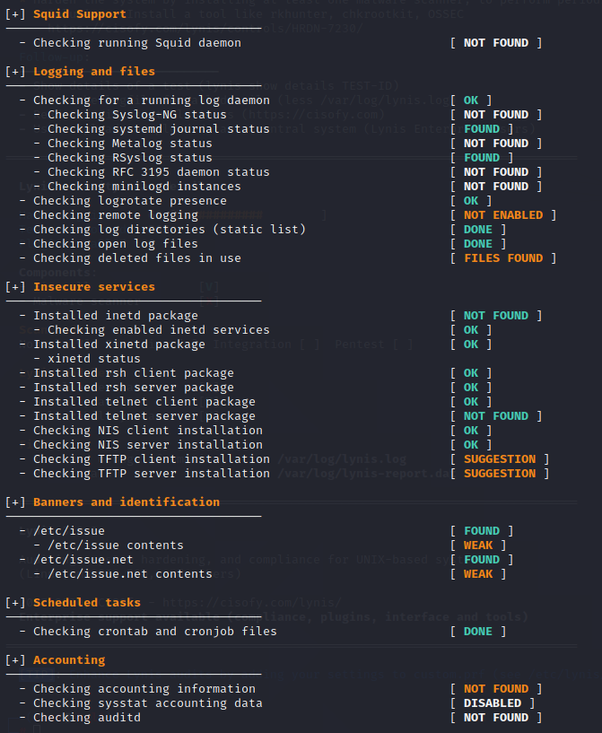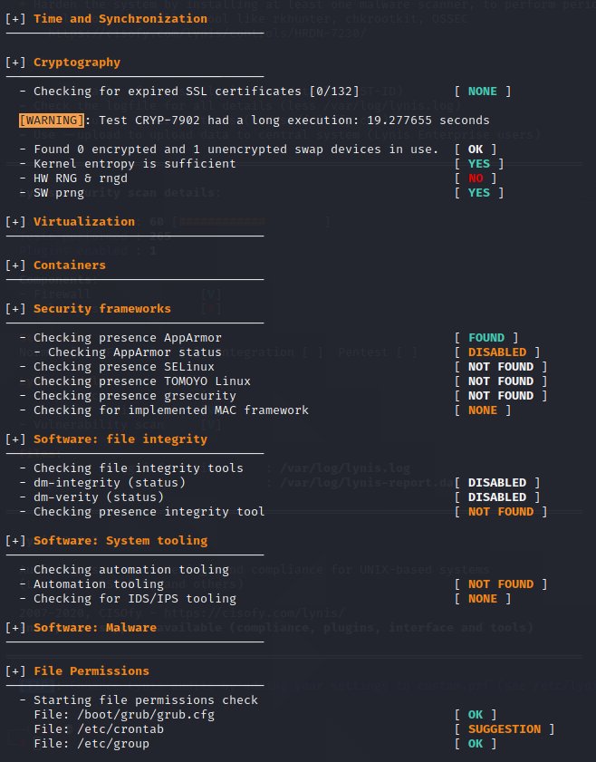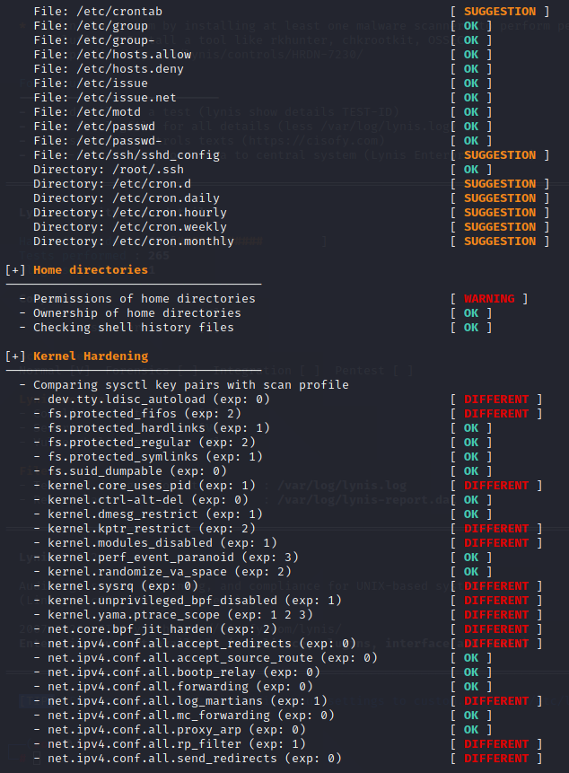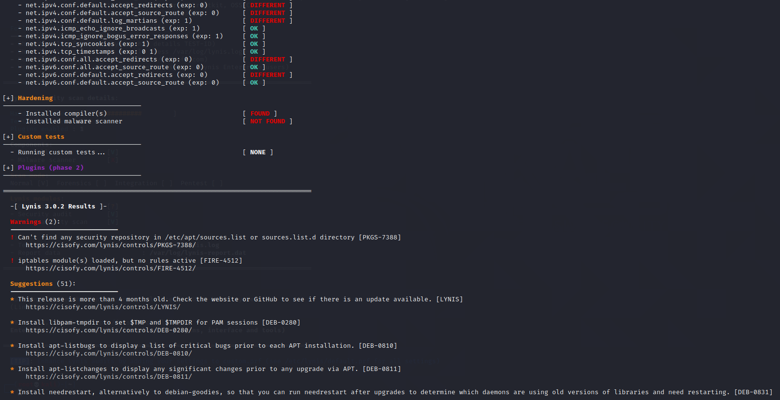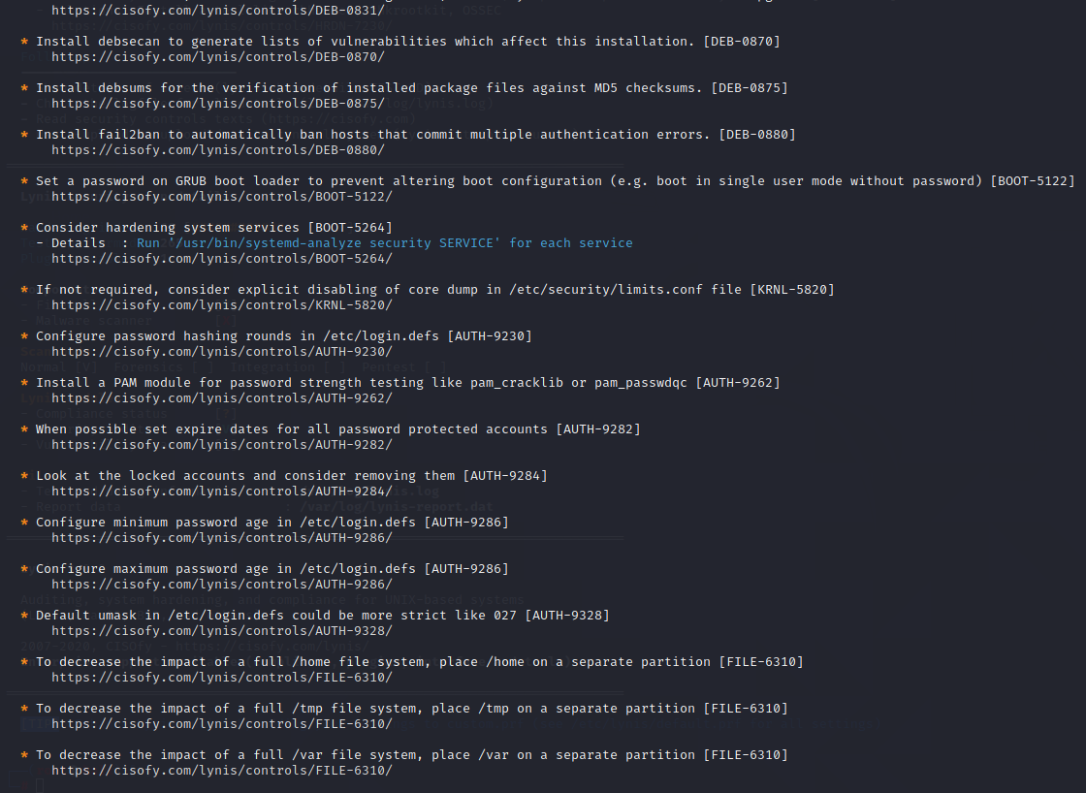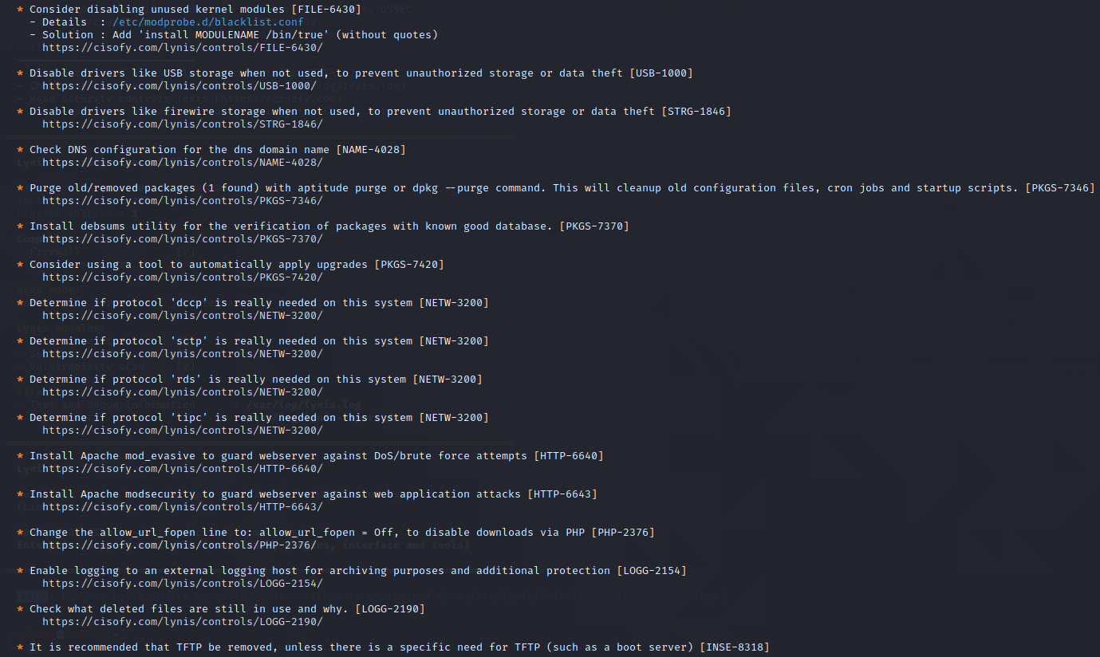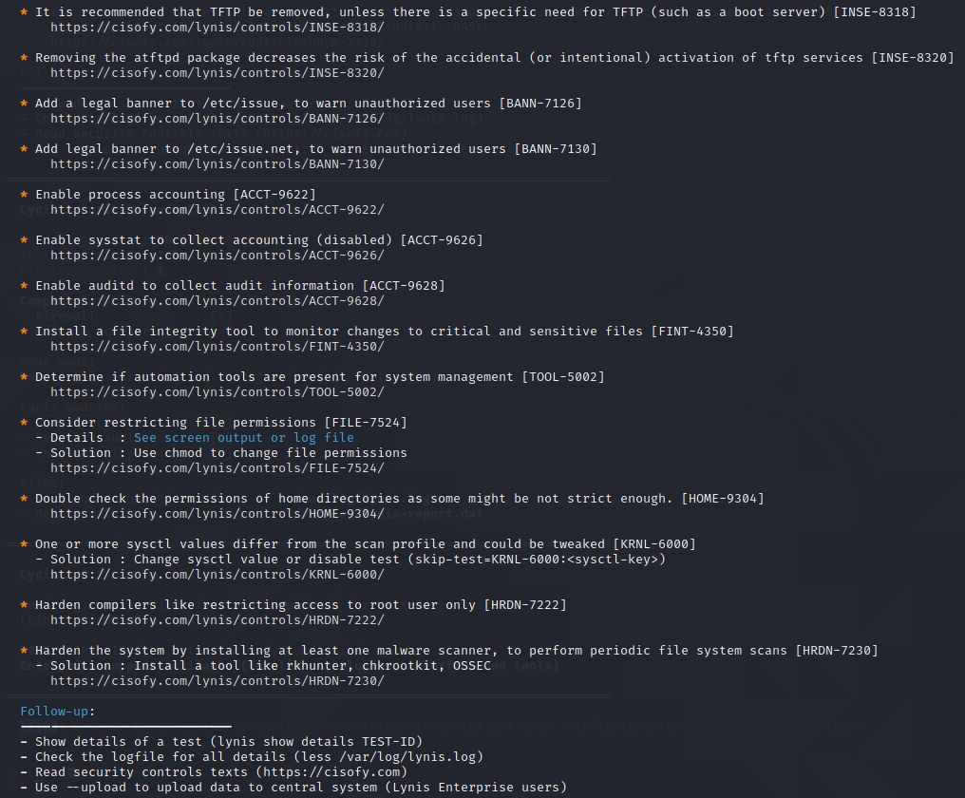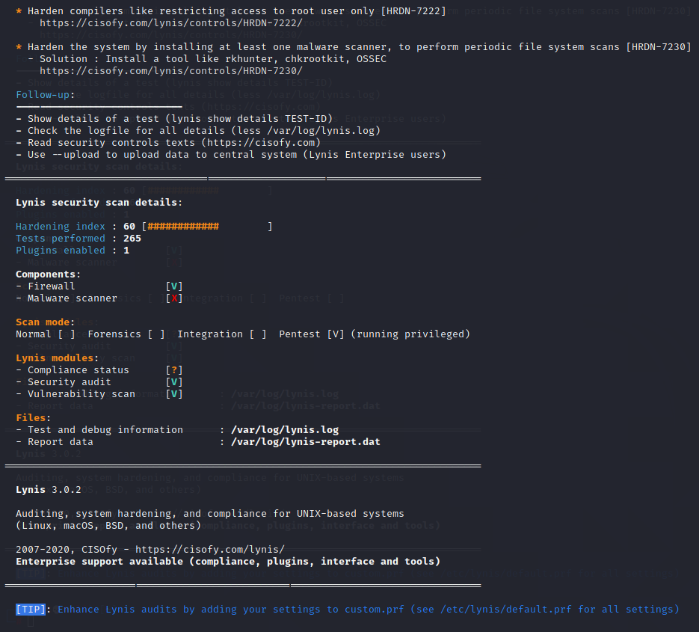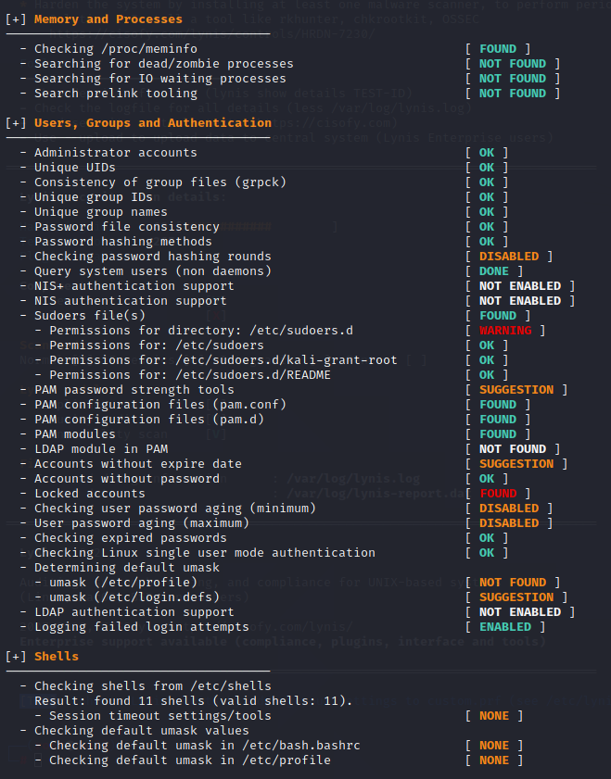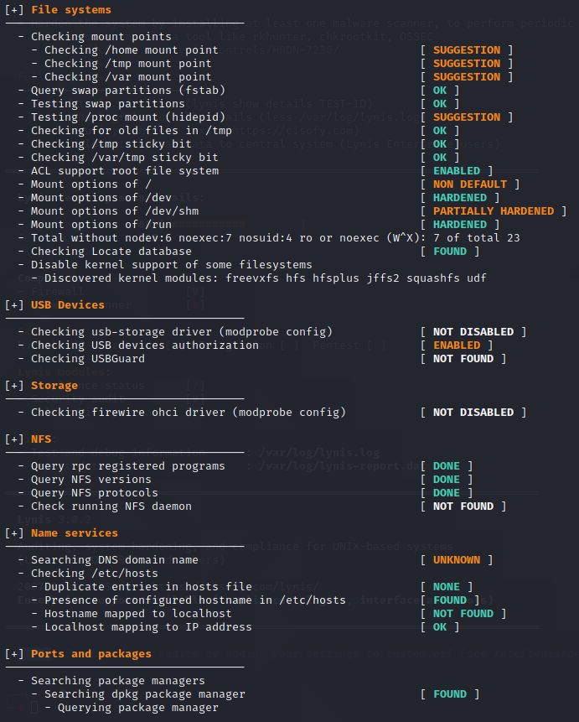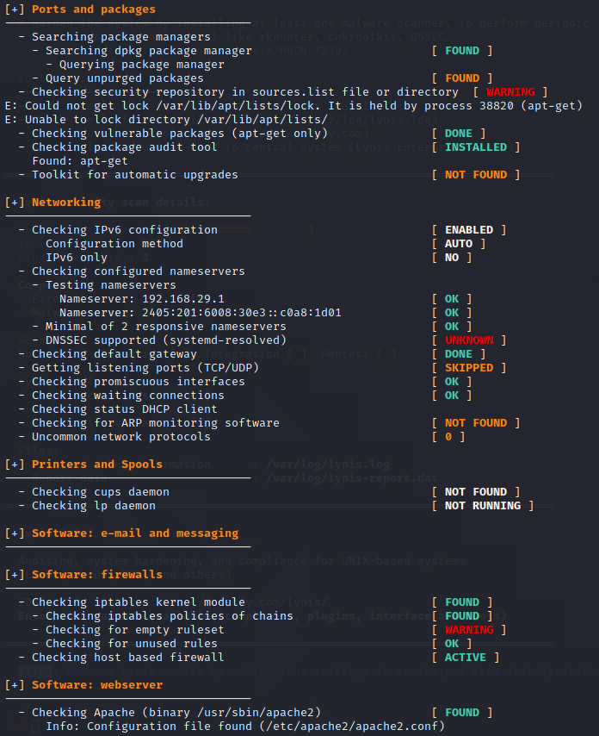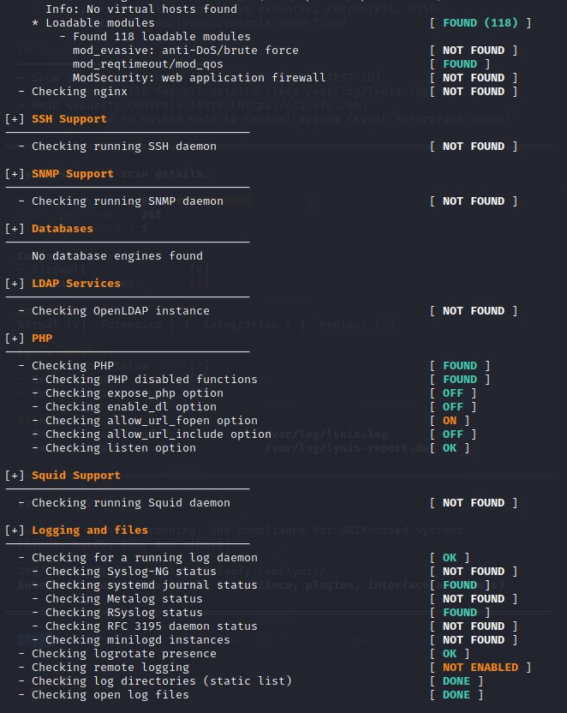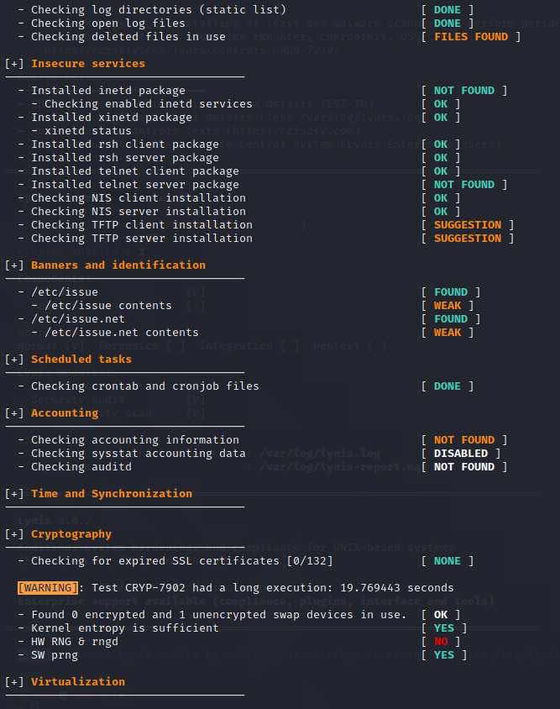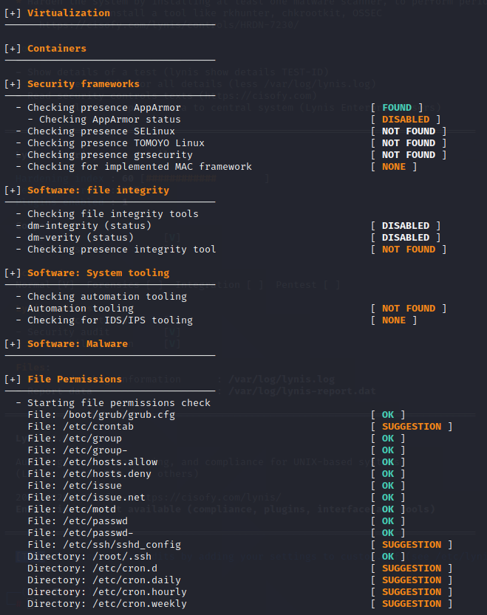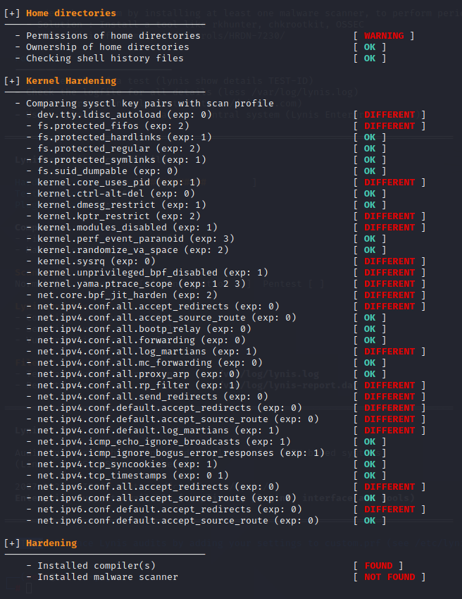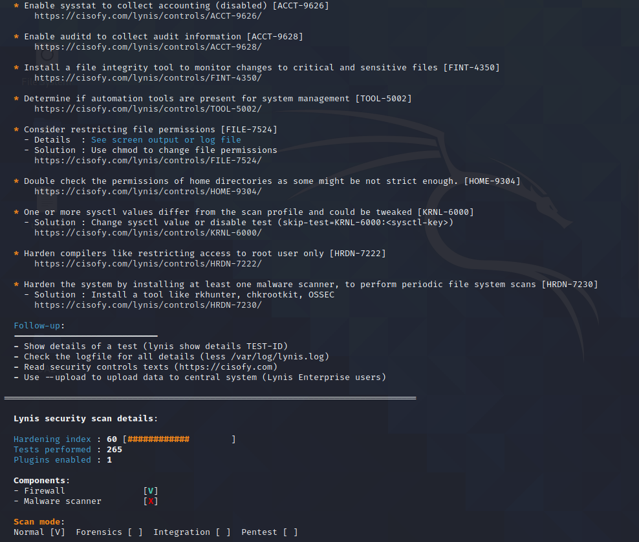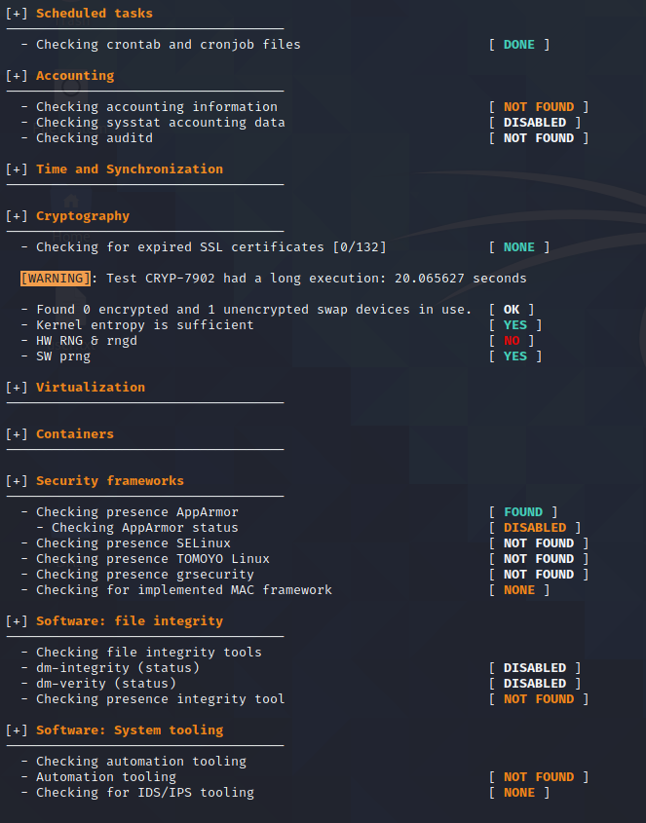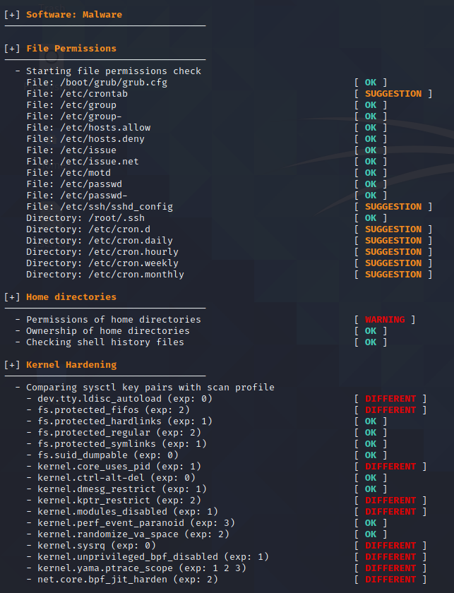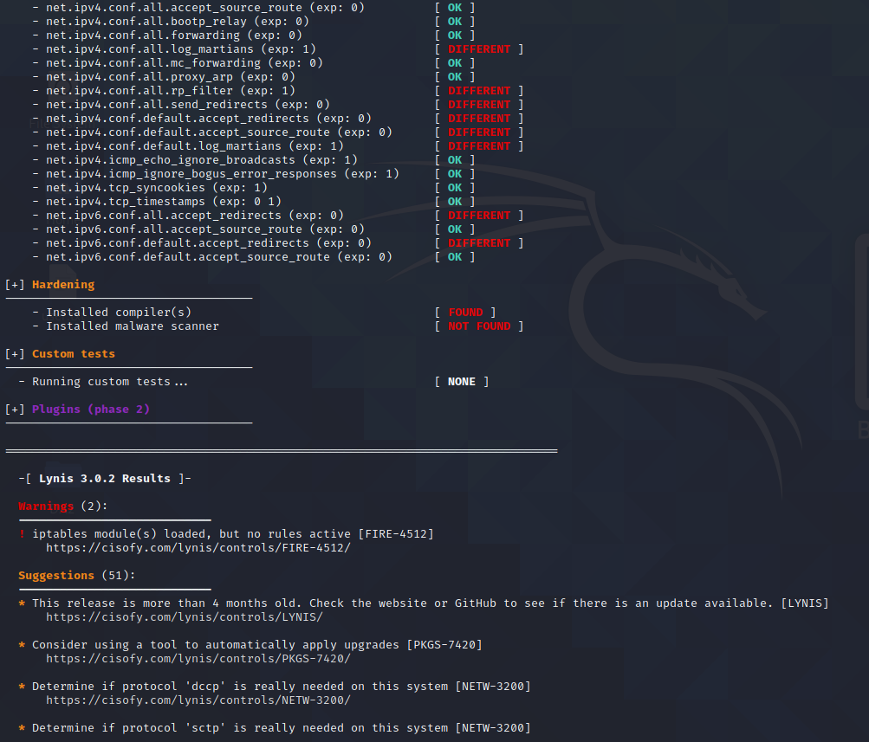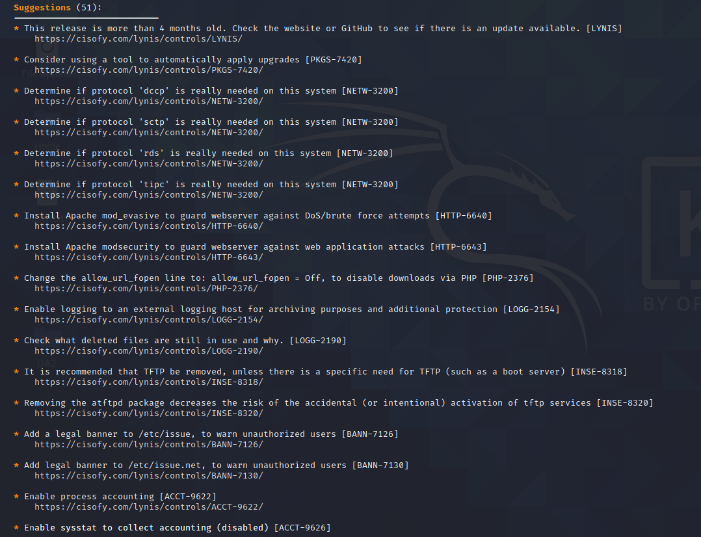

Remotely trying to access contents of phone on same network:

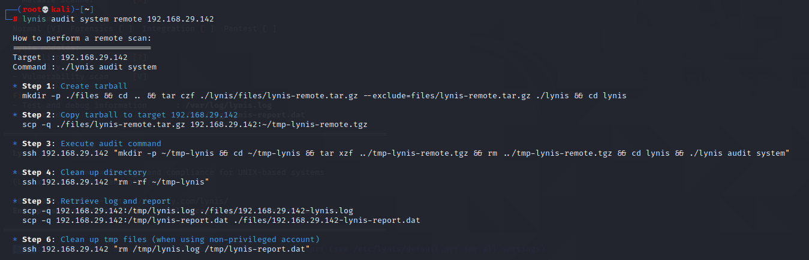

Executing suggestions: 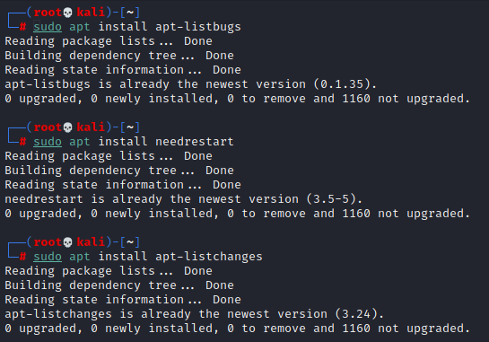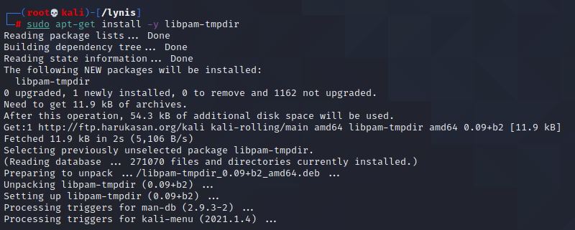

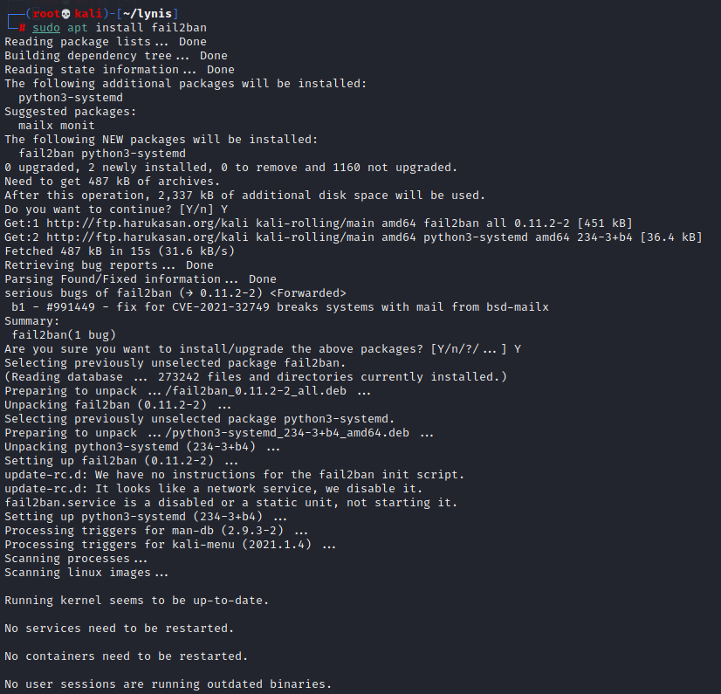 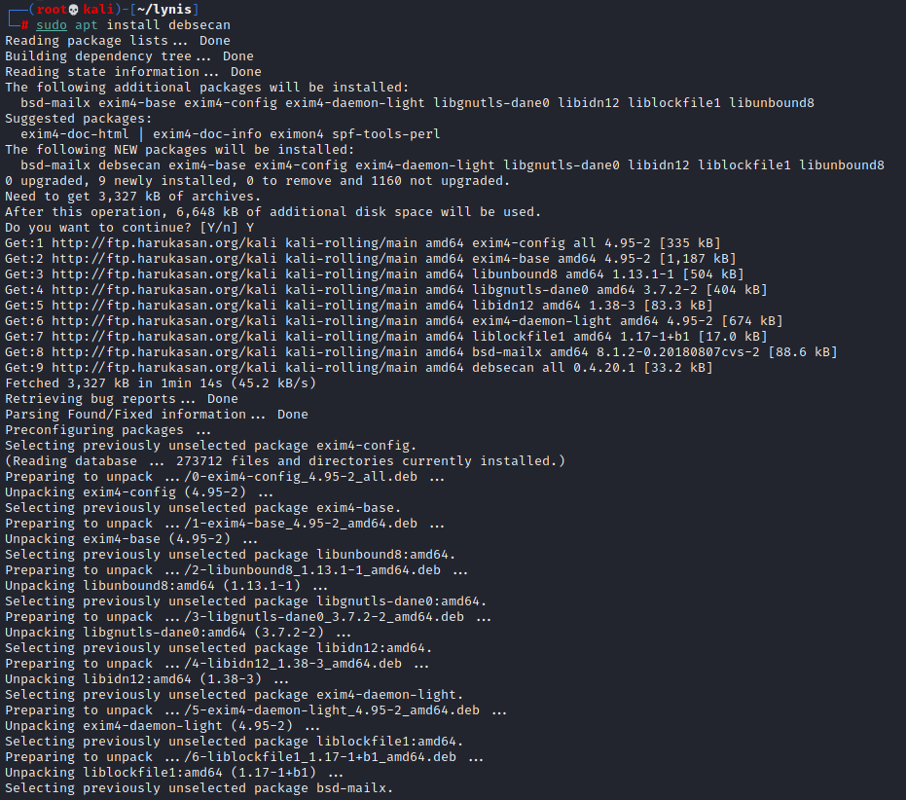 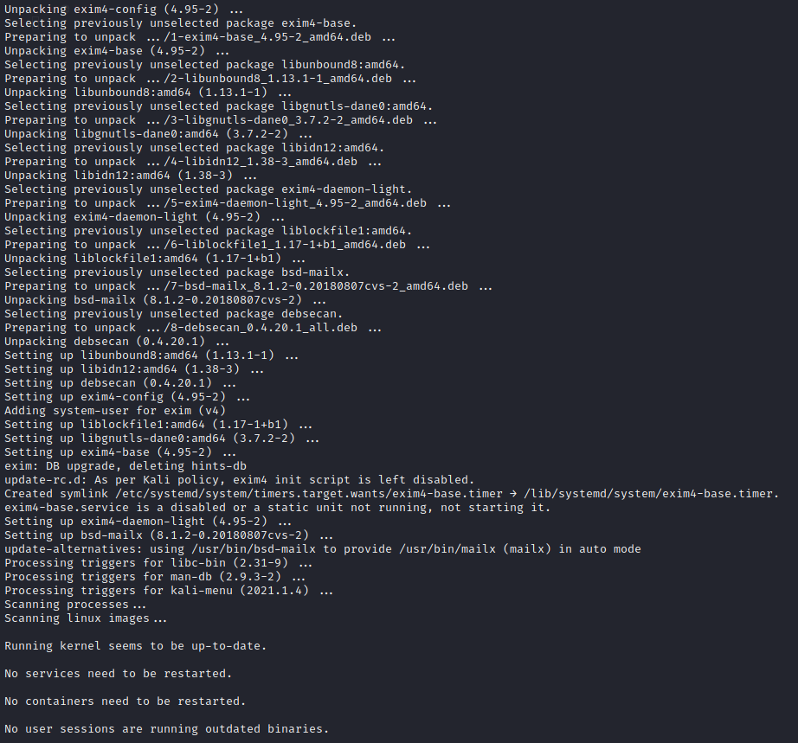 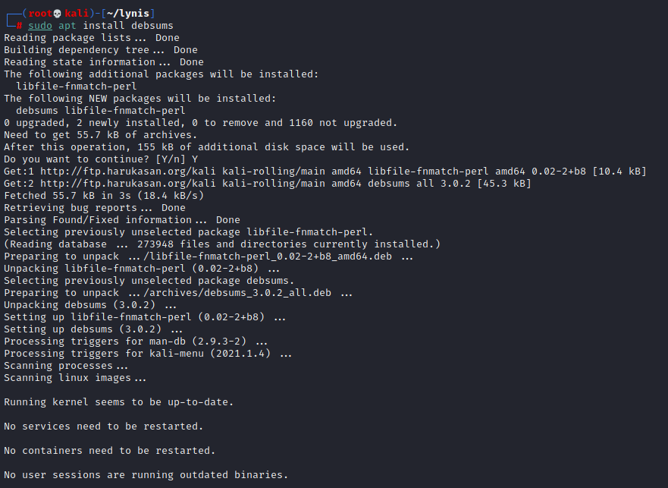

After installing all dependancies and installations,we will see this difference along with normal execution of all above executed commands:

